ENERGY ANALYSIS
Model report
COMPANY NAME
Address
Address

Author:
XXX
Template: March 2023 version

Ref: XXX

The methodology and model documentation for the "Potenzialcheck"
were developed by the engineering consultancy
Énergie et Environnement S.A.

Table of contents
1 INTRODUCTION 4
1.1 Methodology 4
1.2 Summary of proposals 5
1.3 Subsidies 6
1.3.1 Energy suppliers 6
1.3.2 Subsidies from the Ministry of the Economy 6
1.4 Information sources 6
2 General description 8
2.1 Location 8
2.2 Activities 8
3 Energy balance of the building 9
3.1 Gas consumption 9
3.2 Electricity consumption 10
3.3 Hourly distribution of electrical power 11
3.4 Overall balance sheet 12
3.5 Energy costs 13
3.6 Diagram of the main building systems 13
3.7 Reference values - EPI 14
4 Energy use and reduction potential 15
4.1 Heating 15
4.1.1 Energy performance evaluation 15
4.1.2 Measures to reduce energy consumption 15
4.2 Cooling and air-conditioning 17
4.2.1 Energy performance evaluation 17
4.2.2 Measures to reduce energy consumption 17
4.3 Lighting 19
4.3.1 Energy performance evaluation 19
4.3.2 Measures to reduce energy consumption 20
4.4 Ventilation 21
4.4.1 Energy performance evaluation 21
4.4.2 Measures to reduce energy consumption 21
4.5 Energy management 23
4.5.1 Energy management systems – Requirements with guidance for use 24

INTRODUCTION

Methodology
The engineering consultancy XXX was commissioned to carry out an energy analysis of the activities associated with XXX s.à r.l. The scope of this energy analysis covered the building located at XXX in XXX.

The main objective of the energy analysis is to analyse energy consumption (electricity, heat, cooling) and related operating costs. The study aims, then, to determine the precise origins of possible overconsumption by distributing energy consumption among the main uses in order to propose relevant measures to improve the energy performance of the building and systems studied, according to the conceptual scheme illustrated below:

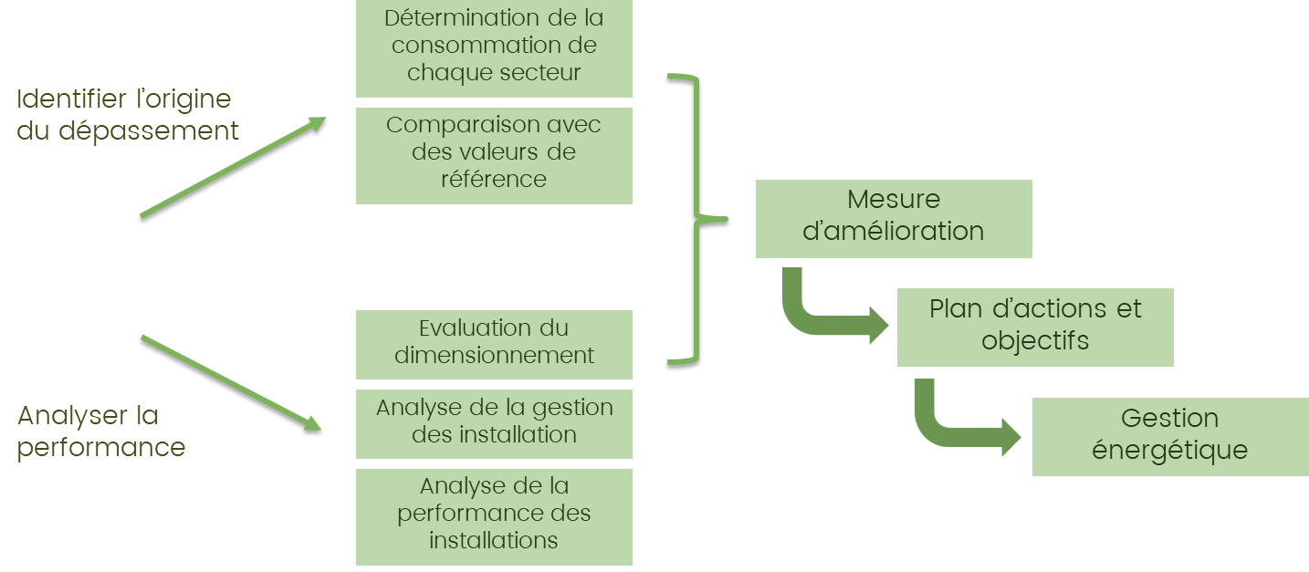

The document is structured into four parts:

- introduction of the study methodology and summary of the proposed measures;
- presentation of the environment and activities relating to the company, distribution and allocation of the related surfaces;
- energy balance of the institution according to the main energy vectors as well as primary energy, CO₂ emissions and energy costs;
- evaluation of the energy performance of equipment systems and thermal envelope elements. Measures to reduce energy consumption are proposed.
Data sheets explaining the details of the implementation of the main measures are provided in the annex to the report.

Summary of proposals
The improvement measures for each energy used are summarised, with symbols used to link the following:

criterion | symbols | range of values
Investment:  the initial capital required to implement the proposed measure | 💸 | between €100 and €1,000
 | 💸💸 | between €1,000 and €5,000
 | 💸💸💸 | between €5,000 and €20,000
 | 💸💸💸💸 | more than €20,000
Savings:  the annual financial gain that can be expected as a result of the improvement measure, expressed as a proportion of the annual cost of energy use | 💡 | 1% to 10%
 | 💡💡 | 10% to 25%
 | 💡💡💡 | 25% to 50%
 | 💡💡💡💡 | more than 50%
Complexity:  the technical/practical difficulty of implementing the measure | 🛠 | Very simple
 | 🛠🛠 | Simple
 | 🛠🛠🛠 | Complex
 | 🛠🛠🛠🛠 | Very restrictive
Time of return on investment (ROI):  the ratio between investment and annual savings, expressed in years | ⏳ | 1 month to 1 year
 | ⏳⏳ | 1 to 3 years
 | ⏳⏳⏳ | 3 to 6 years
 | ⏳⏳⏳⏳ | more than 6 years

The measures are proposed on the basis of the assessment of the improvement potential of each energy use. This is described in more detail following the report.

Overall assessment
- Good energy efficiency in general
- Newly designed building
- Good overall management of equipment and energy (ventilation settings to be checked)
- Consumption mainly related to IT equipment and its cooling
Measures for improving energy performance
no. | Measure | Investment | Savings | Complexity | ROI
Fr1 | Reduction of mechanical cooling output | 💸💸 | 💡💡💡💡 | 🛠 | ⏳⏳⏳⏳
Fr2 | Free-chilling operation for cooling equipment rooms | 💸💸💸💸 | 💡💡 | 🛠🛠🛠 | ⏳⏳⏳
Ec1 | Replacement of fluorescent tubes with LED tubes | 💸 | 💡💡💡 | 🛠🛠 | ⏳⏳

In the annex to this document you will also find fact sheets that explain the following improvement measures in more detail:
- maintenance and checking the efficiency of the heat recovery unit in the ventilation system;
- leak detection in the compressed air network;
- installation of presence and daylight sensors for automatic lighting control.

Subsidies

Energy suppliers
Energy suppliers in Luxembourg have introduced an energy saving subsidy programme. This programme consists of providing a financial subsidy to legal entities or individuals who implement energy-saving measures according to a list of eligible works. The subsidies can be cumulated with any other subsidies.

Subsidies from the Ministry of the Economy

Companies that invest in environmental technologies or environmentally friendly processes can benefit from a special aid scheme. Aid is given in the form of capital grants or interest subsidies.

A simplified guide has been compiled in order to provide guidance to companies in the context of the application of the amended law of 15 December 2017 on an aid scheme for environmental protection. (LINK: https://www.luxinnovation.lu/publication/aides-protection-environnement/)

In addition, an applicant's guide with technical sheets is available to help companies prepare their application file. However, this aid scheme is reserved for large-scale projects.

Within the framework of the SME packages – Sustainability assistance programme, companies will be individually assisted in identifying a concrete solution to reduce their environmental impact, one that will generate savings through reduced energy or water consumption, improved waste management or a reduced carbon footprint.

Information sources

This energy study is based on the plans and documents available at the time of the study and provided by the client, on data collected during the site visit, and on the standards and regulations in force at the time of the analysis. The different standards and regulations used are summarised below.

- VDI 3807: Characteristic values of energy and water consumption of buildings - Sheet 4: Characteristic values for electrical energy
- EN 15251: Indoor environmental input parameters for design and assessment of energy performance of buildings addressing indoor air quality, thermal environment, lighting and acoustics
- EN 12464 - 1: Light and lighting - Lighting of work places - Part 1: Indoor work places;
- EN 13779 - 1: Ventilation of non-residential buildings – Performance requirements for ventilation and room-conditioning systems
- RGD 31.08.2010: Grand-ducal regulation of 31 August 2010 concerning the energy performance of non-residential buildings
- EN ISO 50001: Energy management systems - Requirements with guidance for use (ISO 50001:2011)
- EN 16247-1: Energy analysis – Part 1: general requirements
- EN 16247-2: Energy analysis – Part 2: buildings.

General description

Location

Establishment | Administrative building
Occupant | Company
Address | Address
Year of construction | 2013

Aerial view:

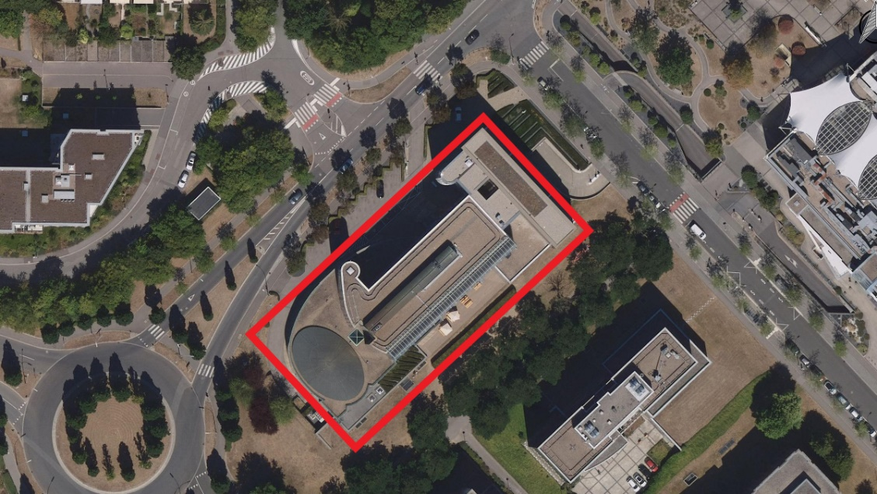
Source: Administration of land register and topography

Activities

Main activity | The company XXX carries out security activities (guarding) and storage of valuables. The building analysed contains offices and secure storage facilities.
Location | Activities by level | Period of occupancy (in general)
Basement | Technical and control rooms  Safe | Monday to Sunday  24h/24
Ground floor | Reception  Meeting rooms, offices | Monday to Friday  5 am - 7 pm
Floors  +1 to +2 | Offices  Meeting rooms | Monday to Friday  5 am - 7 pm
Roof | HVAC rooms | -/-
 | Average number of occupants in the building
Entire building | ~ 70 people from Monday to Friday

Energy balance of the building

Gas consumption

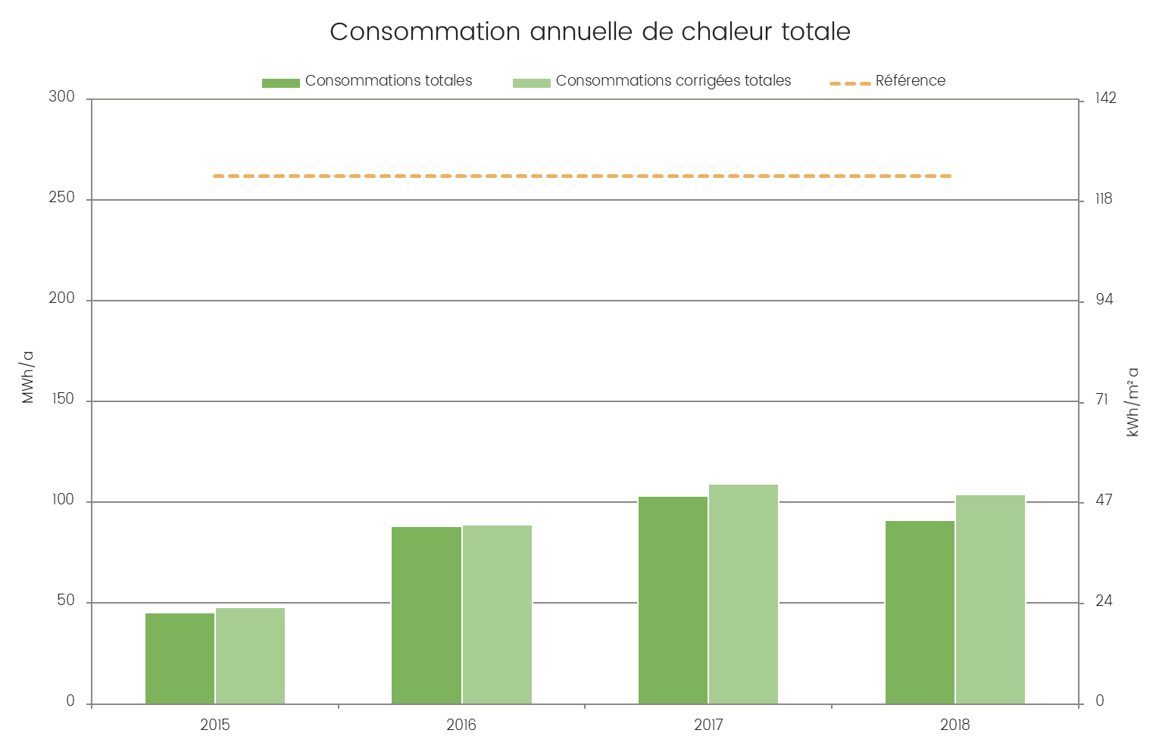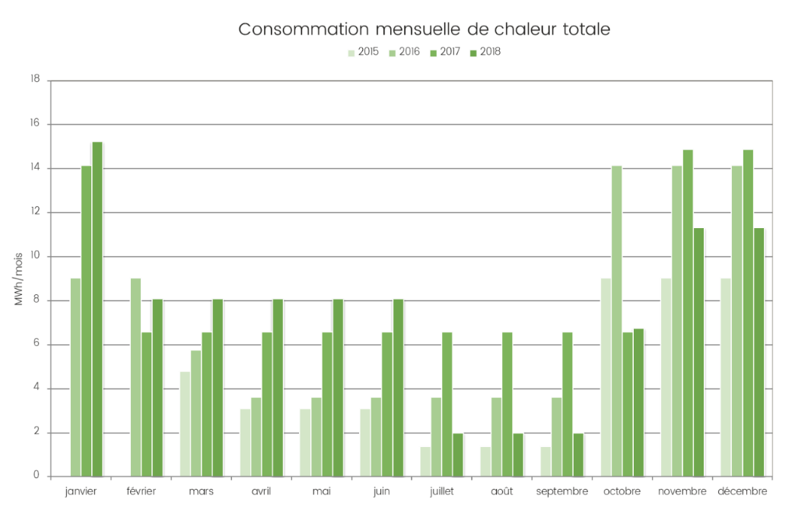

Sum of all meters in the building | Annual consumption [MWh/a]
Average | 94
Change over 4 years | Variable (+/- 10%)
Comment | - Quite variable consumption  - Still well below the reference (~40%)

Electricity consumption

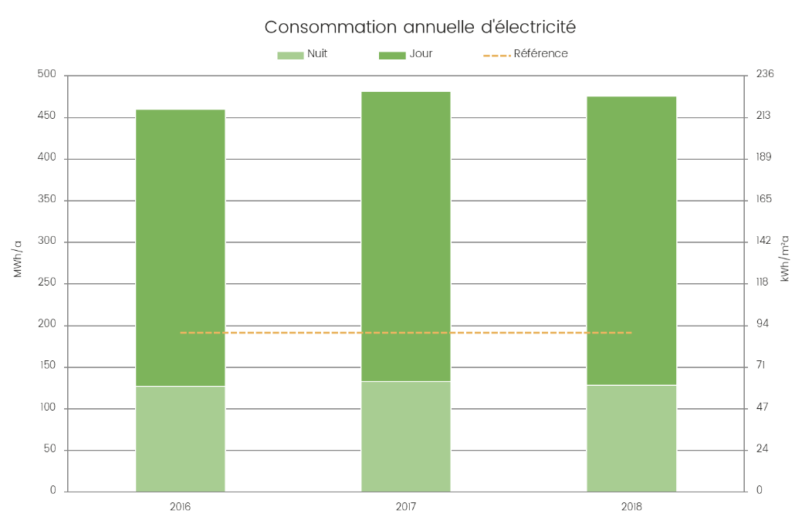
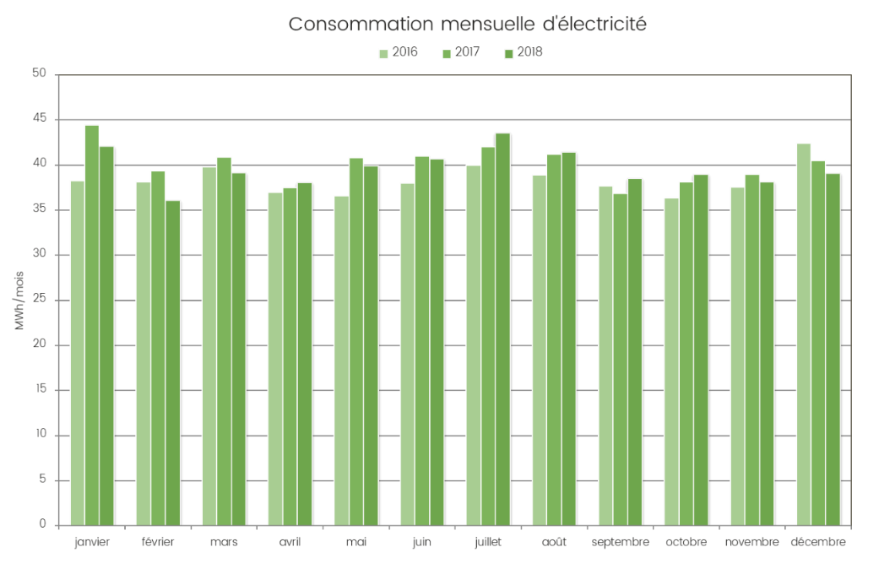

Sum of all meters in the building | Annual consumption [MWh/a]
Average | 472
Change over 4 years | Negligible
Comment | - Constant consumption over the years 2016-2018  - Consumption much higher than the reference due to IT systems and equipment for their cooling, the consumption of which is not perfectly modelled by the calculation method in the Grand-ducal regulation.

Hourly distribution of electrical power
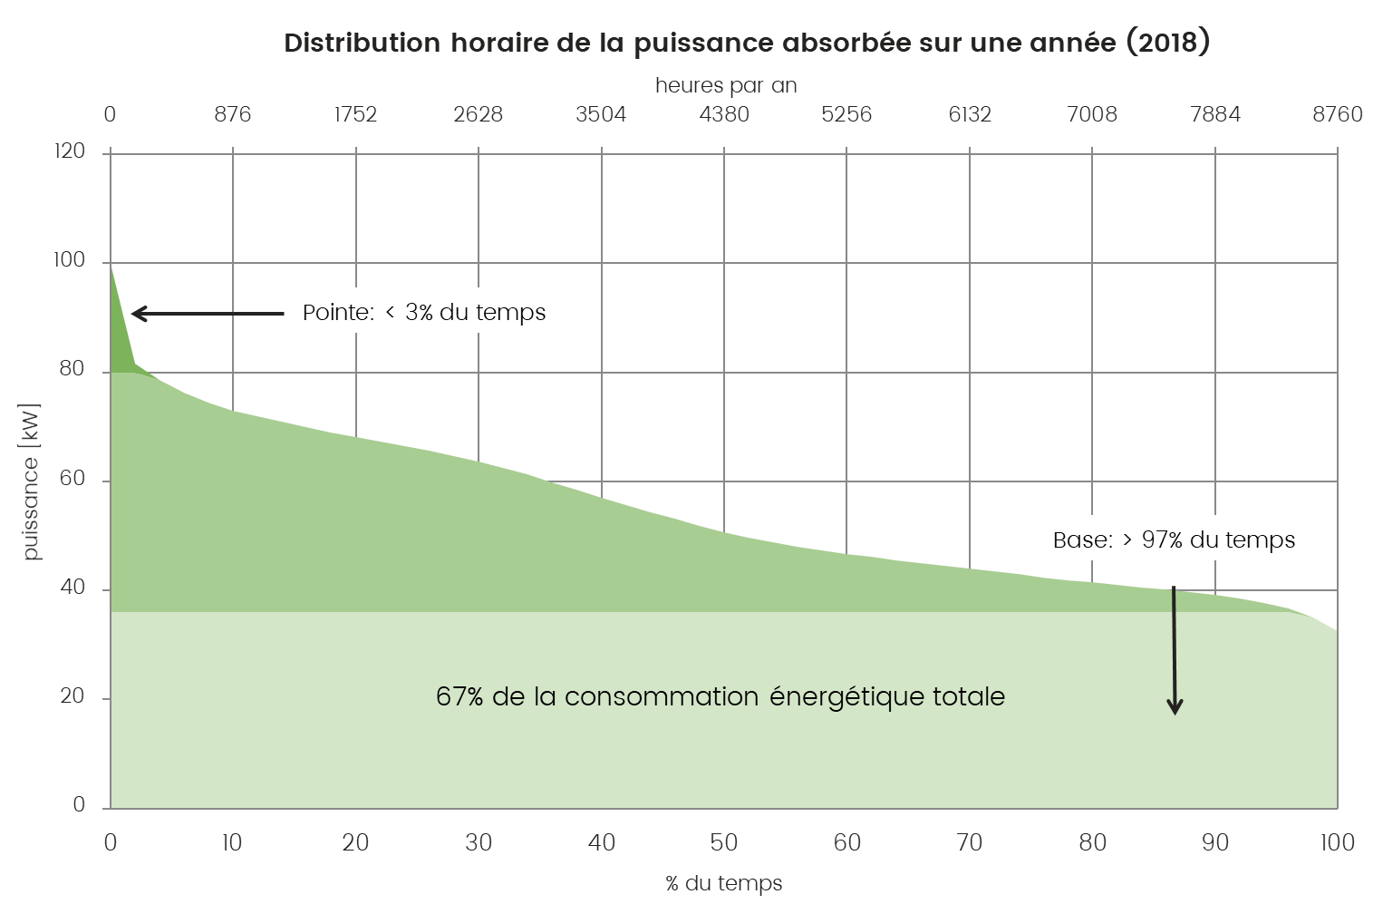
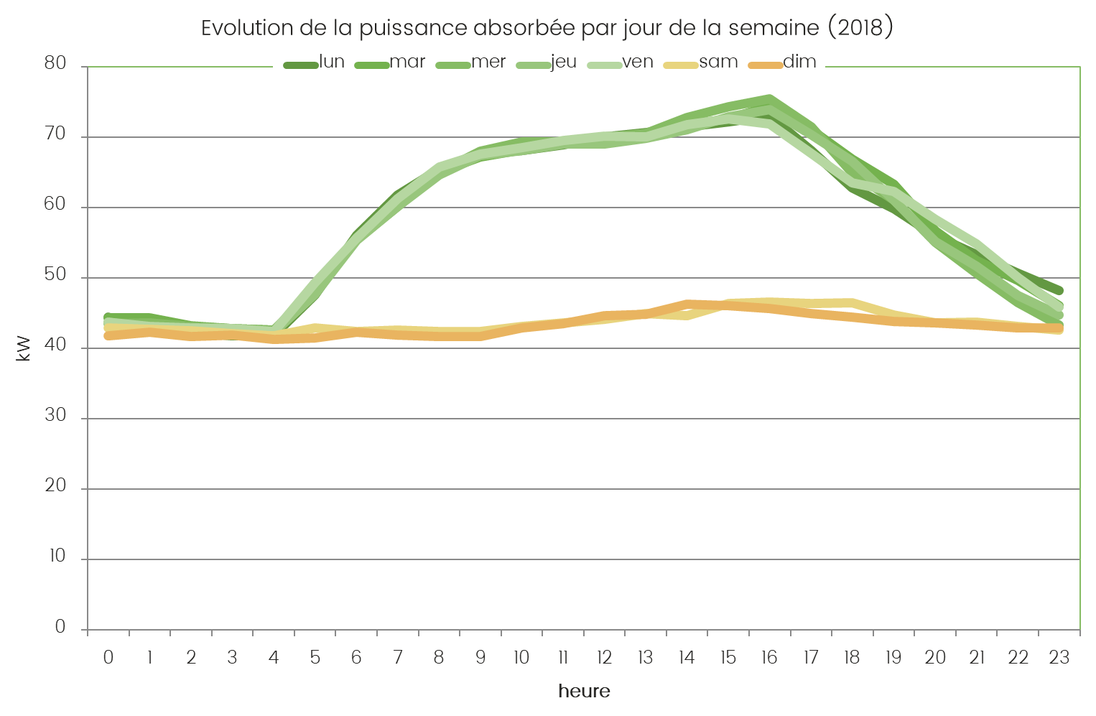

 | Period | Maximum power input [kW]
Week day activity | 5 am – 7 pm | ~75
Activity week night + weekend | 10 pm – 4 am (week)  12 pm - 11 pm (weekend) | ~45
Comment | - Stable and high night-time consumption  - Activity curve during working hours of about +30 kW  - Peak power at 5 pm  - No particular activity at weekends

Overall balance sheet
The consumption weighting in the annual balance sheet in terms of useful and primary energy, CO₂ emissions and cost before tax is shown in the diagram below.

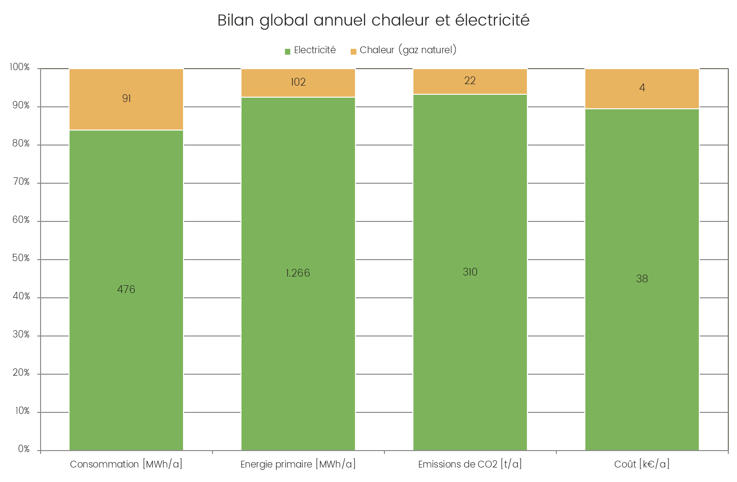

The main energy consumers are the following uses:
- Air-conditioning;
- Heating;
- Lighting.

Energy costs
The different rates paid for the supply of electricity and gas are shown in the table below:

Rates | Electricity | Natural gas
Total price per kWh according to consumption [€/kWh] | 0.079 | 0.048
Comments (in relation to average prices) | Slightly low | Correct

The annual costs of energy supply are broken down as follows:

Annual costs | Electricity | Natural gas
Fixed costs (taxes, grid usage, power premium) | €15,000 | €1,750
Variable costs (energy) | €23,100 | €2,500
Annual total | €38,100 | €4,250

Diagram of the main building systems
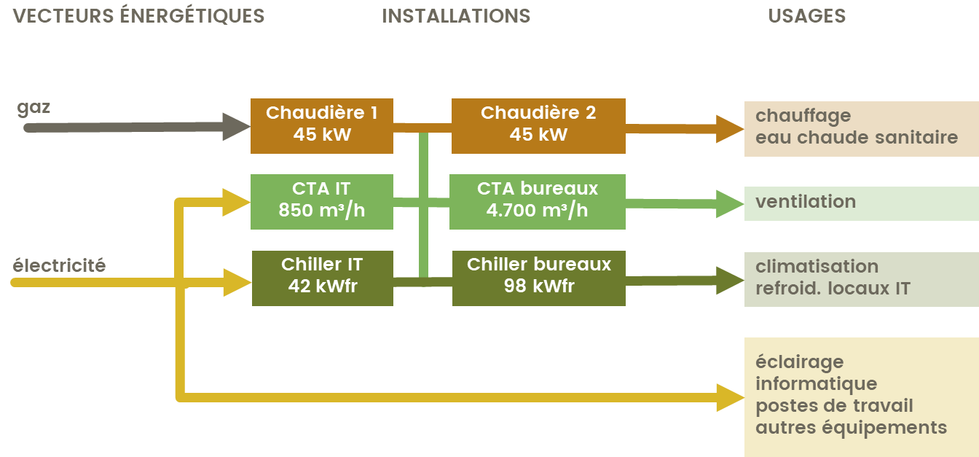
optional

Reference values - EPI
The following summary table shows the reference values determined in this chapter and used for the evaluation of energy efficiency measures.
These values can be considered as Energy Performance Indicators (EPI) according to ISO 50001.

Reference values | Absolute value | Energy Performance Indicator
Total heat consumption | 104 MWh/a | 46 kWh/m²a |  | 1,301 kWh/pers
Total electricity consumption | 476 MWh/a | 238 kWh/m²a |  | 6,798 kWh/pers
Annual heat cost | 4,400 €/a | 2.2 €/m²a |  | 63 €/pers
Annual electricity cost | 37,600 €/a | 18.8 €/m²a |  | 537 €/pers
Periodic variables
Overall price of electricity | 0.079 €/kWh
Overall price of heat | 0.048 €/kWh
Static factors
Energy reference area | 2,117 m²
Number of staff (max.) | 70 |  | 0.035 people/m²
Hours of occupancy | 5 am – 7 pm Monday to Friday

Energy use and reduction potential

Heating

Energy performance evaluation

Thermal insulation of the envelope
Thermal envelope | Characteristics and observations | Evaluation
EEC | Energy efficiency class of envelope “D” (97% of the reference value)
Walls to outside | Maximum U-value according to EEC: 0.32 W/m²K
Slab to floor or unheated rooms | Maximum U-value according to EEC: 0.40 W/m²K
Roof | Maximum U-value according to EEC: 0.25 W/m²K
Windows | Double glazing and aluminium frames, maximum U-value 1.5 W/m²K
Comment | - Thermal performance of the envelope in accordance with the regulatory requirements of the Grand-ducal regulation of 31.08.2010 on the energy performance of non-residential buildings

Heat production system
The building is heated by two gas-fired condensing boilers, each with an output of 45 kW. The same system also supplies domestic hot water via a storage tank.

Heat distribution in the building
Heat is distributed by equipment with the following characteristics:

Distribution | Characteristics | Photo/Diagram
Heat carrier | Water | 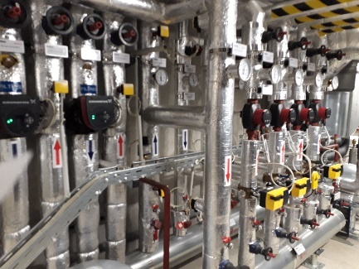
Distribution temperature | n.a.
Distribution networks | Reversible ceilings  Radiators  Fan convectors  Heating coils (fan units)
Comments | Most of the pumps have frequency inverters

Measures to reduce energy consumption
Ch1 – Regulation of the setpoint on AHUs
Situation | During the visit to the building, it was noted that the temperature of the air heaters was too high (especially in summer)
Proposal | Regulate the setpoint temperature as a factor of outside temperature
Evaluation | Investment | Savings | Complexity | R.O.I
 | 💸💸💸💸 | 💡💡💡💡 | 🛠🛠🛠🛠 | ⏳⏳⏳⏳

Cooling and air-conditioning

Energy performance evaluation
Sun protection
The facades of the building have a transparent surface of less than 50%. The building also has manual external slatted blinds on the southern facade and internal blinds for the other orientations, resulting in average overall solar protection.

The east- and west-facing facades, in particular, receive an equivalent amount of solar radiation to the south-facing facade during the summer months. These facades should have the same sun protection as the south facade.

Cold production system
The company has a cold production system for cooling IT equipment and another for the air-conditioning.

Chiller | Characteristics | Photo/Diagram
Area and facilities served | IT premises
Make - Model | GEA GLAC 2015
Type of unit | One-piece compressor
Number of compressors | 2
Heat output [kW_{el}] | 18.9
Nominal output [kW_{fr}] | 41.8
Refrigerant | R410A (6.5 kg)
Location | Roof

 | Characteristics and observations | Evaluation
Sun protection | No sun protection | 🔴
Cold production system | COP = 3.5 | 🟡

Measures to reduce energy consumption
Fr1 – Reduction in cooling output
Situation | During the visit to the building it was noted that the temperature in the IT areas was lower than in the offices.  The cooling of these areas is therefore oversized in relation to their needs.
Proposal | Increase the setpoint temperatures to 28°C for the IT areas, i.e. regulate cooling production
Evaluation | Investment | Savings | Complexity | R.O.I
 | 💸💸💸💸 | 💡💡💡💡 | 🛠🛠🛠🛠 | ⏳⏳⏳⏳

Fr2 – Free-chilling operation for cooling equipment rooms
Situation | Of the two chillers units, the one dedicated to air-conditioning (GEA GLFC) can be operated in free-chilling mode. This method does not seem to be used correctly according to the power consumption curve in the cold season.
Proposal | Since both chillers operate in the same temperature range and feed the same buffer tank, it is recommended to make maximum use of the possibility to produce chilled water by free-chilling and the same for cooling the IT systems. Check the setting of this operating mode so that it can be used correctly when the climatic conditions allow it.
Evaluation | Investment | Savings | Complexity | R.O.I
 | 💸💸💸💸 | 💡💡💡💡 | 🛠🛠🛠🛠 | ⏳⏳⏳⏳

Lighting

Energy performance evaluation
Natural lighting
The daylight entering the building is described in the table below:

Parameters | Value
Architecture: | perimeter offices with ribbon window, traffic areas in the centre of the area (without windows)
External screens: | no external screens to neighbouring buildings
Light transmission factor τ of the glazing: | 70-80%
Average depth of the premises in relation to the window: | Individual office | ~ 5 m
 | Open space | ~ 5 m
Artificial lighting
The management of interior lighting is essential in the space, depending on needs, and over time, depending on the presence of people and the natural light available. The lighting system for the company is described in the table below:

Zone | Type of lighting | Output | Estimated quantity | Regulation
Offices | Fluorescent tubes | 25 W | ~1000 | Presence detector
Traffic | Fluorescent tubes | 40 W | ~50 | O  Automatic on/off
Comment |  | Good system performance

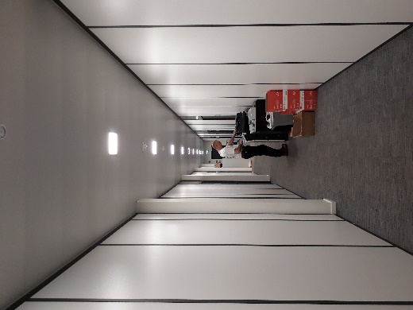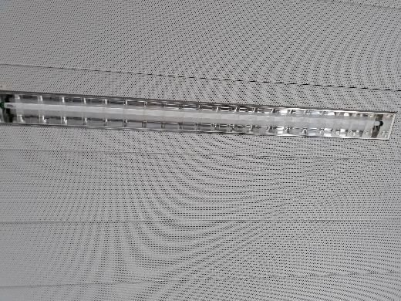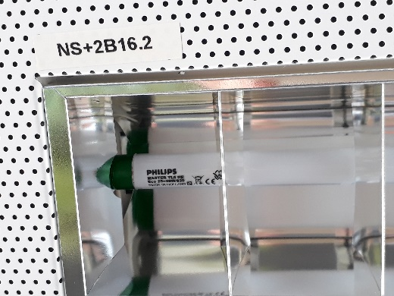
Tubes and luminaires in corridors and offices

Lighting efficiency
Type of light |  | Luminous efficiency [lm/W] | Presence on company premises
Compact fluorescent light |  | 40 to 65 | Yes
Fluorescent light (electronic ballast) |  | 71 to 100 | No
LED light |  | 20 to 150 | Yes
High-pressure sodium-vapour light |  | 57 to 122 | No
Comment | - The lighting efficiency of the system is good (approx. 100 lm/W)

 | Characteristics and observations | Evaluation
Natural lighting | Good availability of natural light | 🟢
Artificial lighting | Fluorescent tubes | 🟡
Regulation | Presence detectors | 🟢

Measures to reduce energy consumption
Ec1 – Replacement of fluorescent tubes with LED tubes
Situation | The building is equipped entirely with fluorescent lighting.
Proposal | It is proposed to replace the fluorescent tubes with LED tubes with the same light output but lower energy consumption and a longer life span.
 | Current tube  PHILIPS Master TLS HE Eco 25=28W1830  2,600 lm  25 W  3,000 K  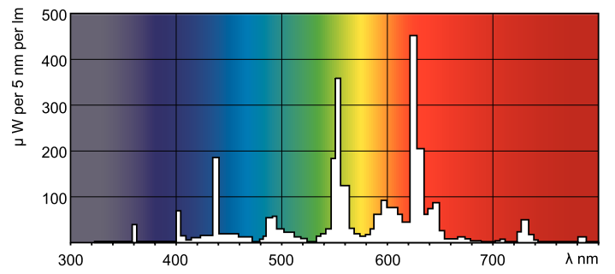 |  |  | Proposed tube  PHILIPS MASTER LED tube InstantFit HF T5  2.300 lm  16.5 W  3,000 K  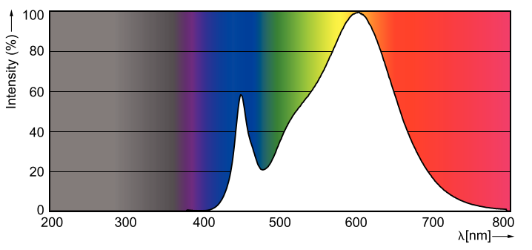
Evaluation | Investment | Savings | Complexity |  | R.O.I
 | 💸💸💸💸 | 💡💡💡💡 | 🛠🛠🛠🛠 |  | ⏳⏳⏳⏳

Ventilation

Energy performance evaluation
Description of ventilation systems
The ventilation systems at the site have the following characteristics:

Office ventilation | Characteristics | Photo/Diagram
Affected area | Offices | 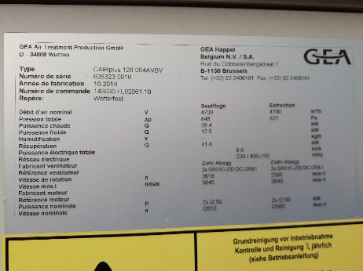
Function | Supply/Extraction
Brand | GEA Happel
Number of fans | 2 suppliers + 2 extractors
Energy recovery | 41.8 kW
Supply air flow rate [m³/h] | 4,700
Extraction air flow rate [m³/h] | 4,700
Total rated electrical output of the motors [kW] | 10
Hot group | Yes
Cold group | Yes
Humidification | No
Location | Equipment room roof

Area/system | Area  [m²] | Maximum occupants | Flow rate (class 2) | System flow rate | Oversize ratio
Entire building | 2,117 | 70 | ~6,500 | 5,550 | 85%
Comment | - System slightly undersized in relation to the building's nominal requirement

 | Characteristics and observations | Evaluation
System efficiency | Correct | 🟡
Sizing | Slightly undersized | 🟡
Regulation | In operation 24/24 | 🔴

Measures to reduce energy consumption
Ve1 – Regulation of time programming
Situation | The ventilation is always on
Proposal | It is proposed to modify the centralised programming of the ventilation to match the hours of activity the company.
Evaluation | Investment | Savings | Complexity | R.O.I
 | 💸💸💸💸 | 💡💡💡💡 | 🛠🛠🛠🛠 | ⏳⏳⏳⏳

Energy management
Principle
The analysis presented in this report has identified the sources of the building's energy consumption and devised measures to improve energy efficiency. Systematic energy management may be indicated in order to ensure the best use of the results of the analysis and to enable efficient management in the future.

The aim of the energy management system is to achieve a continuous improvement in energy management within a company. The methodology is based on an initial analysis of the state of the system (in this case the energy analysis), which establishes a baseline. The four phases then continue periodically in the following order:
- Plan: carry out an energy analysis, define energy performance indicators, objectives, targets and action plans to improve energy performance in line with the organisation's energy policy;
- Do: implement the energy management action plan;
- Check: monitor and measure the parameters characterising energy performance;
- Act: carry out actions to continuously improve energy performance.
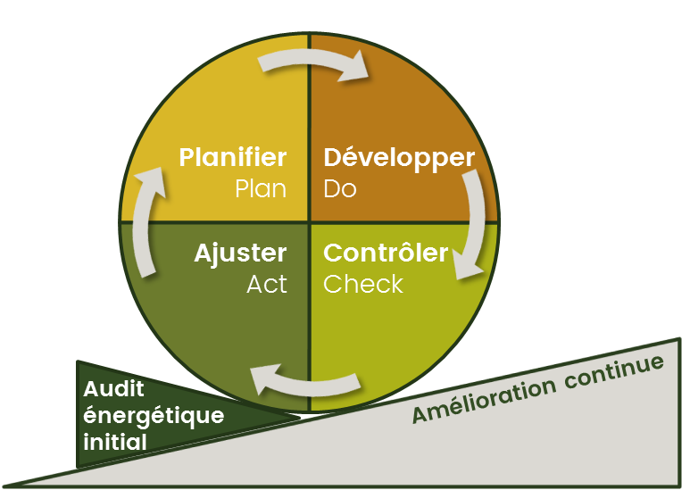
Energy management process pursuant to ISO 50001:2011

Energy management systems – Requirements with guidance for use
Occupant behaviour and awareness
Designation | Current situation | Action to be taken
User behaviour | Regular switch-off policy for workstations | None
Awareness | No ongoing awareness campaign | Carry out awareness activities (stickers, posters, emails)

Operational control - maintenance
Designation | Current situation | Action to be taken
Air-conditioning | Well-maintained cooling unit | None
Cooling | Well-maintained cooling unit | Increasing the temperature set point in equipment rooms
Ventilation | Well-maintained air handling unit | Hourly regulation and effective flow/power to be checked
Lighting | Automatic regulation | None

Monitoring of energy consumption
Designation | Current situation | Action to be taken
Heat | No monitoring of consumption | Analyse consumption in order to avoid drift
Electricity | No monitoring of consumption by usage | Analyse consumption in order to avoid drift  Use sub-meters present in the building

Purchasing policy
Designation | Current situation | Action to be taken
General purchase | No specific information | Establish a procedure for evaluating tenders according to energy efficiency criteria
Information for suppliers | No specific information | Systematically inform suppliers that the company will take energy efficiency into account when analysing proposals

